Experiment-1
1.RM Command
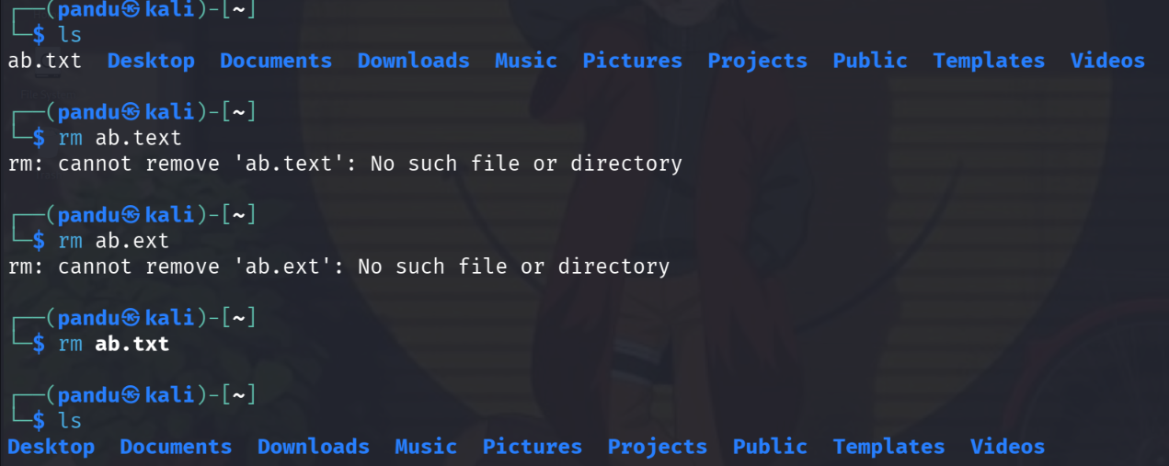
The rm is used to delete/remove the files
2.Users command
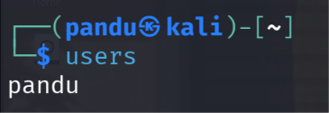
Users command is used to show the what are the users in the system
3. Tree Command
Tree command is used to show the file directories
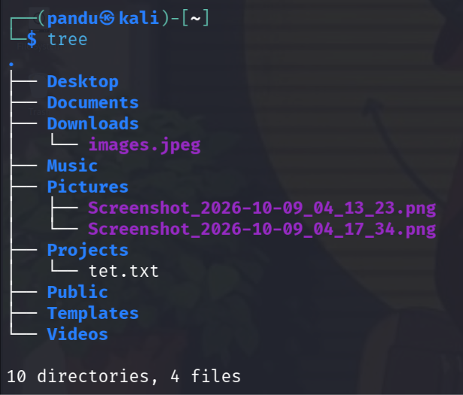
Experiment-2
- Less Command
Less command is used to show the content in the file
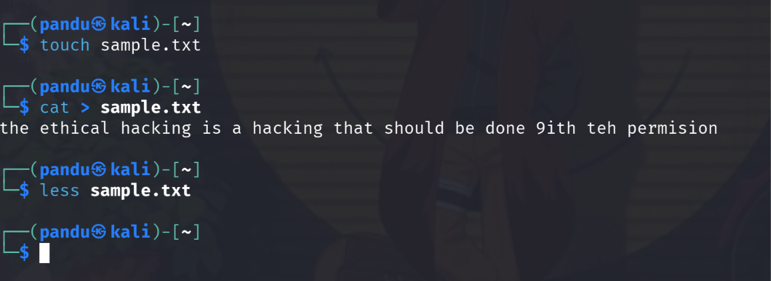
2.More Command
The more command displays a text file one screen at a time. It is mainly used to read long files page by page.
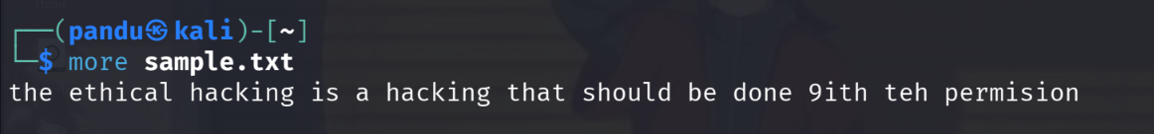
3.VI Command
Vi Command is used to edit the files
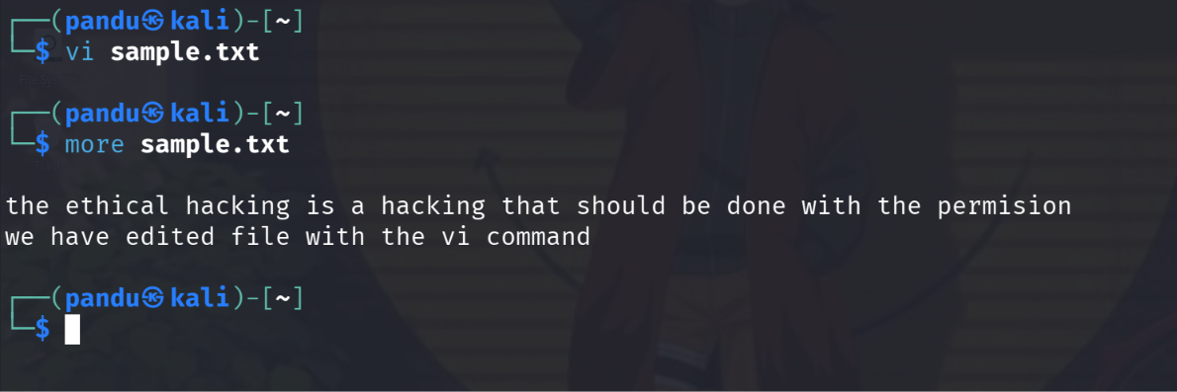
Experiment-3
Tree Command
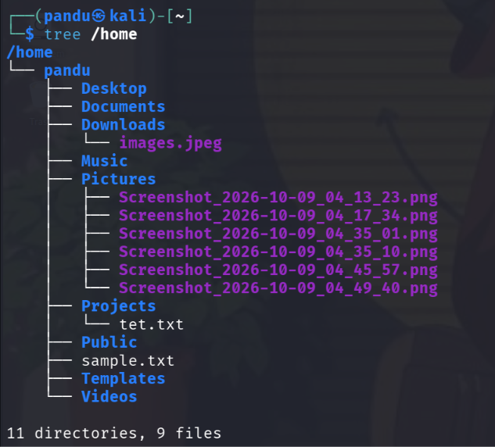
Tree command is used to display the directories and the files present in the folder
Head command
It is used to print the last insert text in the file
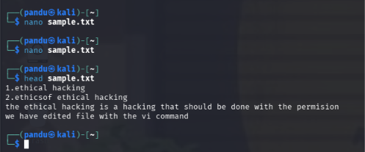
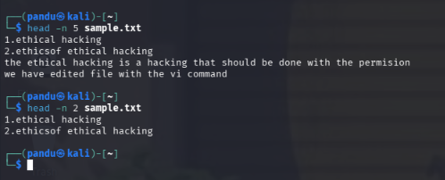
Tail Command
It is used to print the last elements in the file
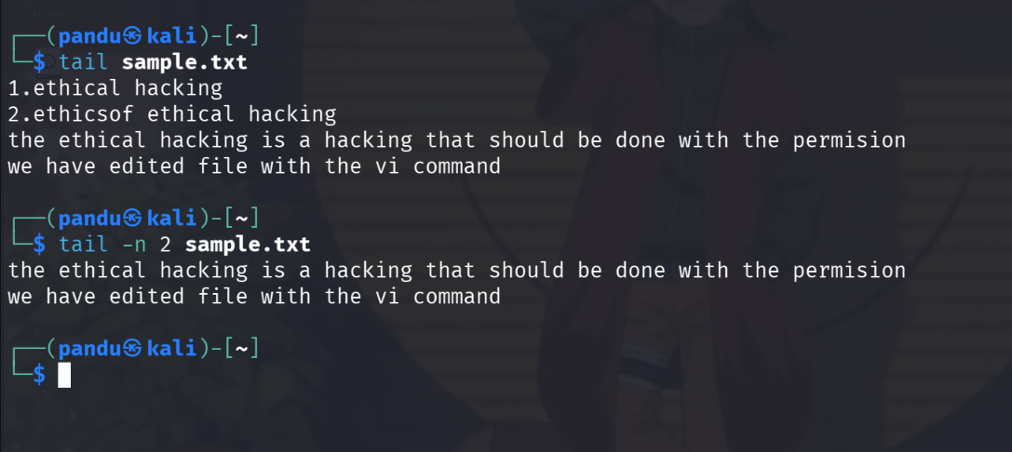
Experiment-4
Ls Command
The ls command is used to list files and directories in the current directory.
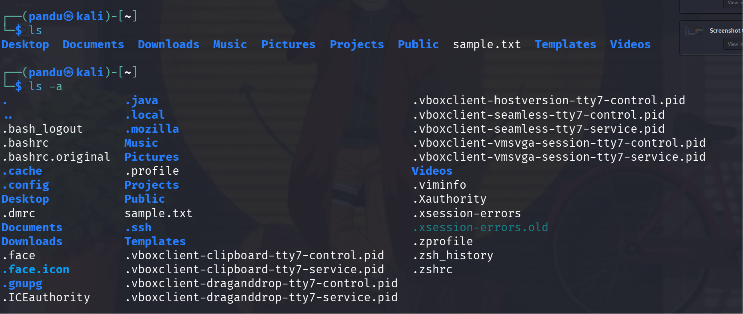
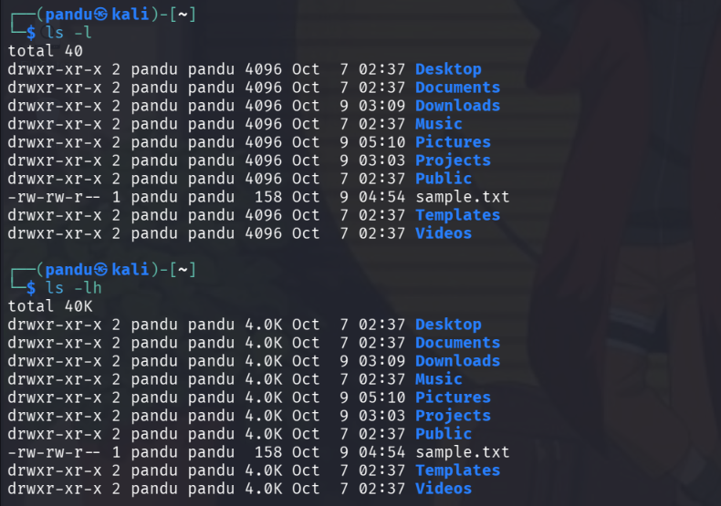
• ls -l — Displays detailed file information.
• ls -a — Displays hidden files and directories.
• ls -lh — Displays file sizes in a readable format.
cat Command
The cat command is used to display file contents, create text files, and combine files.
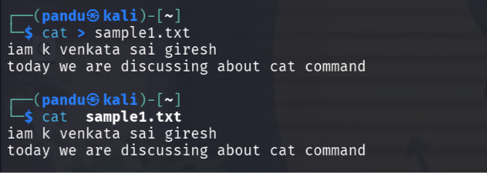
mkdir Command
About: The mkdir command is used to create new directories (folders) in Kali Linux.
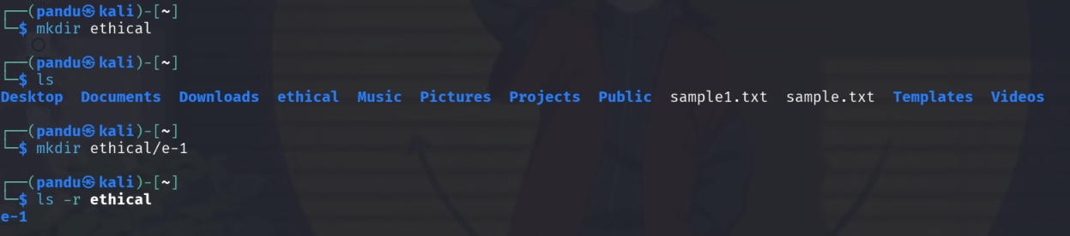
Experiment-5
uptime Command
The uptime command displays how long the system has been running, the number of currently logged-in users, and the system load averages.
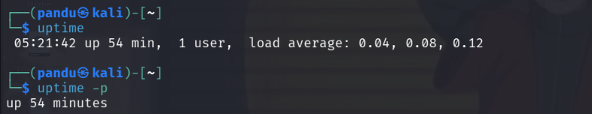
Date Command
About: The date command displays the current system date and time. It can also format the output according to the user's requirements.
